 | 8.1.3 Editors - Image Editor - Header - View menu
Table of content
Image Editor - View Menu 2
Toolbar 2
Sidebar 2
Tool Settings 2
Adjust Last Operation 2
Set 2D Cursor 3
Annotations (Legacy) 3
Draw Annotation 3
Draw Line Annotation 3
Draw Polyline Annotation 3
Erase Annotation 3
Add Annotation Layer 3
Erase Annotation Active Keyframe 3
Zoom In 3
Zoom Out 3
Zoom Border 4
Fractional Zoom 4
Frame All 4
View Fit 4
Render Region 4
Clear Render Region 4
Render Slot Cycle Next 4
Render Slot Cycle Previous 4
Center View to Cursor 4
Area 5
Horizontal Split 5
Vertical Split 5
Duplicate Area into New Window 5
Toggle Maximize Area 5
Toggle Full screen Area 5
Close Area 5
Pie menus 5

Image Editor - View Menu

The View menu contains all View related tools.
It is available in all sub modes. With a render result the view image shows a different content. And in mask mode it shows one more item. Set 2D cursor.

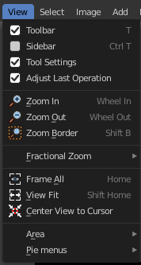
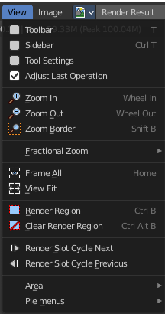
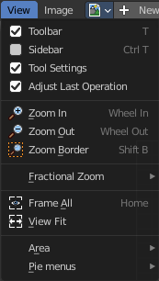
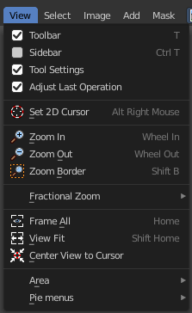

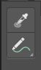
Toolbar
Shows or hides the toolbar at the left.

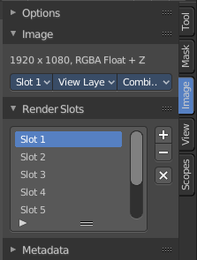
Sidebar
Shows or hides the sidebar at the right in the viewport.

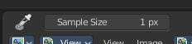
Tool Settings
Shows or hides the tool settings above the header in the 3D view.

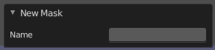
Adjust Last Operation
Shows or hides the Adjust Last Operation panel down left.

Note that the Adjust Last Operation menu item in the Edit menu in the main header and the Last button in the toolbar are not related and not functional with this last operator panel. It is an independent element.

Set 2D Cursor
Mask mode only. Set the 2D cursor position. Hotkey only tool! Please use the hotkey!

Annotations (Legacy)
This group of operators is useful to take notes without changing tool-shelf operators. These notes can be colored in the View tab of the Property Shelf. Each layer is a single color. You can also animate the notes with keyframes, editable in the dopesheet.
Note: These are legacy operators, meaning they are equally available in the Toolshelf as a modal operator.

Draw Annotation
Starts the annotation free hand draw tool in the editor.

Draw Line Annotation
Starts the annotation line draw tool to draw straight lines in the editor.

Draw Polyline Annotation
Starts the annotation Polyline draw tool in the editor which allows to draw multiple connected straight lines in the editor.

Erase Annotation
Starts the annotation erase tool in the editor which erases any strokes in the editor.

Add Annotation Layer
Starts a new annotation layer.

Erase Annotation Active Keyframe
Erases the active keyframe of the annotation.

Zoom In
Zooms into the viewport.

Zoom Out
Zooms out of the viewport.

Zoom Border
Draws a rectangle and zooms then to fit the size of this rectangle.
Zooming in is done with drawing the rectangle with left mouse button. Zooming out is done with drawing the rectangle with middle mouse button.

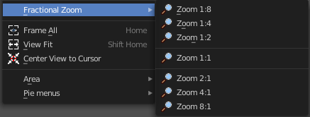
Fractional Zoom
A sub menu where you can choose between predefined zoom factors.

Frame All
Zooms in or out in the viewport until all objects in the scene are displayed fitting in the viewport.

View Fit
Zooms out or in to fit the image to the viewport.

Render Region
Render result only. Allows you to draw a rectangle. And when you re-render the image, just the content in this rectangle region gets rendered.
This tool does, different from the 3d view, not draw a permanent red rectangle to define the render region area. You will see what you have chosen when you render the image.

Clear Render Region
Render result only. Removes any existing render region rectangle.

Render Slot Cycle Next
Render result only. Cycle through the Render slots.

Render Slot Cycle Previous
Render result only. Cycle through the Render slots.

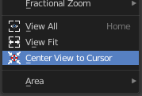
Center View to Cursor
Mask Mode only. Center the view to the 2D cursor.

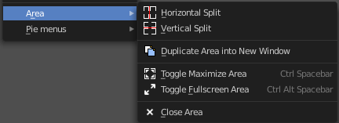
Area
This menu contains general view functionality. And exists in most other editor types too.

Horizontal Split
Splits the current view horizontally into two independent editor windows.

Vertical Split
Splits the current view vertically into two independent editor windows.


Duplicate Area into New Window
Duplicate Area into New Window makes the selected editor window floating. You can then drag it around at the monitor. It is not connected with the rest of the UI any more.
A separated window cannot be merged into the main window again. You have to close it when not longer needed.

Toggle Maximize Area
Displays the editor maximized with menus.
To return from the maximized view press hotkey ctrl + spacebar. Or reuse the menu item in the area menu.

Toggle Full screen Area
Displays the editor maximized without menus.
To return from the full screen view press hotkey ctrl + alt + spacebar.

Close Area
Closes the area window.

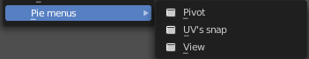
Pie menus
Lists the available pie menus, and gives you the ability to read the hotkeys and assign own hotkeys.

